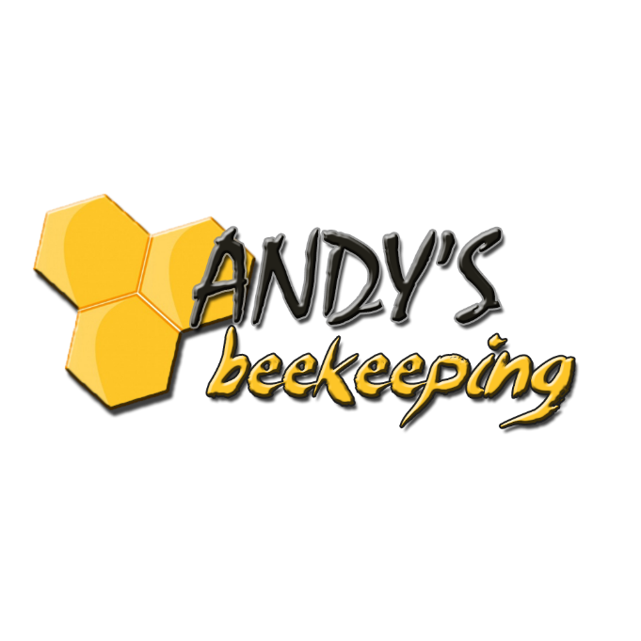
129 Ronald L. Swafford Rd.
Pikeville, TN 37367
1 (423) 653-6859
www.AndysBeekeeping.com
AndrewSwafford@AndysBeekeeping.com

Fundraising
Wholesale Wholesale Retail Price
(National FFA Organization) (Other Organizations)

Lip Balm: $1.00 $1.50 $2.00
Flavors: Black Cherry, Mango, Pina Colada, Pomegranate, Spearmint, Vanilla

Hand Salve: $3.00 $3.50 $5.00
Scents: Black Cherry, Cucumber Melon, Lemongrass, Sandalwood, The Tropics

Honey: Prices for Individual Containers, Sold by Cases of 12 or 24.
Clover Wildflower

½ Pound $3.00 $4.00 $6.00
Pint $6.00 $8.00 $10.00
Quart $11.00 $14.00 $16.00

Straw Bundles of 100 for $25 ($0.25 each) $0.50 each

